School of Engineering and Applied Science, Ahmedabad University

Cloud Computing

Project Definition

Group – 2

**Mentor:** - Dr. Sanjay Chaudhary

**Title**: - Cloud Based Compiler

**Introduction**

Build cloud based web application that provides developer an interface which helps in code compilation, execution, analysis and also provides code optimisation related suggestion if required in code.

**Services**

* Service related to code compilation
  + If code is compiled successfully then service related to execution of code
  + Provide analysis of code like how much memory is used, how much time taken by code for execution etc.
* If code is compiled and executed successfully then code optimisation service will be executed and it will suggest user possible ways to optimize code if required.

**Physical design**

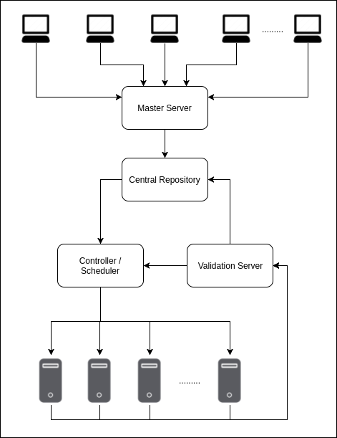

**Logical Design**

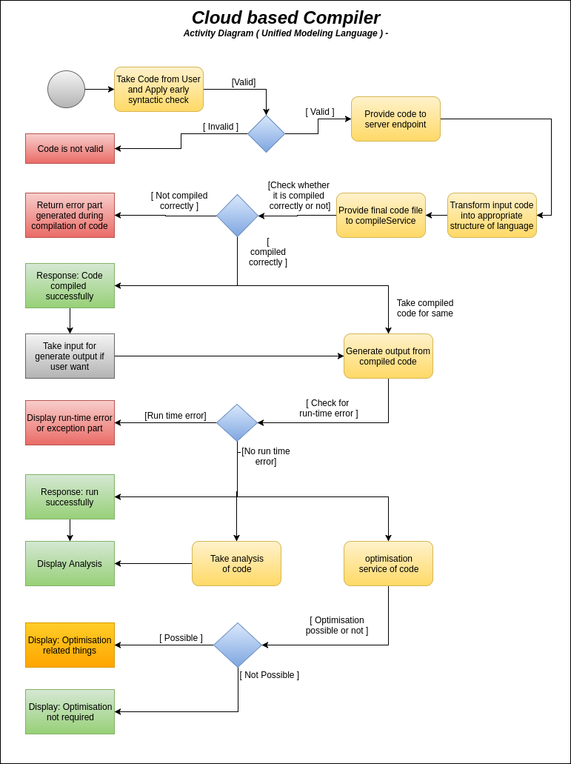

**Timeline and Task division**

Initially, web application will provide compilation for C language or Java language only. Services will be implemented in Python or Java.

|  |  |  |  |
| --- | --- | --- | --- |
| No. | Task | Tentative Deadline | Executor |
| 1 | Implement a code which helps in parsing and storing source code in central repository | 22/09/2017 | Ashutosh Kakadiya |
| 2 | Compiler setup on virtual machines (servers) (Parallel to 1 Task) | 24/09/2017 | Harsh Mehta & Mihir Gajjar |
| 3 | Implement scheduler which controls multiple jobs (for code compilation and execution) in efficient way | 30/09/2017 | Ashutosh Kakadiya & Shreyas Patel |
| 4 | Code which helps in compilation and execution of source code and also maintains logs of it | 07/10/2017 | Shreyas Patel & Harsh Mehta |
| 5 | Code which take action according to compilation process, will make changes in central repository and notify user for it | 14/10/2017 | Mihir Gajjar & Harsh Mehta |
| 6 | Testing and integration of services | 28/10/2017 | All |
| 7 | Make required changes and put the services live ready for use | 04/11/2017 | All |

**Team Members**

* Ashutosh Kakadiya - 1401075
* Harsh Mehta - 1401085
* Mihir Gajjar - 1401076
* Shreyas Patel - 1401025

**References**

* Ansari, Aamir Nizam, Siddharth Patil, Arundhati Navada, Aditya Peshave, and Venkatesh Borole. "Online C/C++ compiler using cloud computing." *2011 International Conference on Multimedia Technology*, 2011. doi:10.1109/icmt.2011.6002124.
* Ghaleb, Taher Ahmed. "Toward open-source compilers in a cloud-based environment: the need and current challenges." *2015 International Conference on Open Source Software Computing (OSSCOM)*, 2015. doi:10.1109/osscom.2015.7372684.
* Datta, Arjun, and Arnab Kumar Paul. "Online compiler as a cloud service." *2014 IEEE International Conference on Advanced Communications, Control and Computing Technologies*, 2014. doi:10.1109/icaccct.2014.7019416.